

|  |  |
| --- | --- |
| **Qualification** | **New Zealand Diploma in Software Development**  **New Zealand Diploma in Web Development and Design** |
| **Course** | **5008 Programming** |
| **Level** | **5** |
| **Assessment Number** | **1 (Project)** |
| **Assessment Version** | **V1** |
| **Term & Year** | **Term 3, 2018** |
| **Campus** | **Auckland** |

|  |  |  |  |
| --- | --- | --- | --- |
| **Assessment** | **Date** | **Time allowed/Due Date** | **Submission type** |
| **Project** | **21/05/2018** | **Due: 23:59 pm, Friday. 20th June 2018** | **Upload your files to Moodle in a zipped folder** |

|  |  |  |
| --- | --- | --- |
| **Learning Outcomes** | 1. Use procedural and Object-Oriented programming. 2. Write applications using design patterns. 3. Write applications using appropriate data structures and algorithms. 4. Select and apply appropriate data validation techniques. | **Total Weighting**  **100%** |

|  |  |  |  |  |
| --- | --- | --- | --- | --- |
| **Learning Outcome** | **Task** | **Marks Available** | **Weighting** | **Marks Awarded** |
| **2** | **1** | **25** | **25%** | **/25** |
| **1** | **2** | **25** | **25%** | **/25** |
| **4** | **3** | **20** | **20%** | **/20** |
| **3,1** | **4** | **20** | **20%** | **/20** |
| **3,4** | **5** | **10** | **10%** | **/10** |
| **Total marks** | | **100** | **100%** | **/100** |

|  |  |  |
| --- | --- | --- |
| **Tutor/Assessor** |  | |
| **Marks:** | **Grade:** |  |

|  |
| --- |
| **Assessment Instructions:** |
| * This is an individual project. It must be your own work. * Do not copy the source codes or project of others. * Complete the student declaration and submit it as part of your answer * Complete all tasks. * Take note of the due date/time to complete. If you have circumstances that mean you cannot complete the work on time discuss it with your tutor **before** the due date. * Work submitted after due date, without prior negotiation with the tutor or programme leader will not be marked. (Please, refer to NZDSD, NZDWDD programme regulations). * The name of your project Folder should be labelled by your student ID. |
| **STUDENT DECLARATION** |
| I declare that this is my own work.  If this assessment is submitted electronically I understand that by entering my student ID below, this declaration will be deemed to have the same authority as a signed statement. |
| Student ID:2018001446 |
| Date:19 June 2018 |

Submitted by: Kurul Vyas

Id No:2018001446

1.) The hierarchical structure of classes:

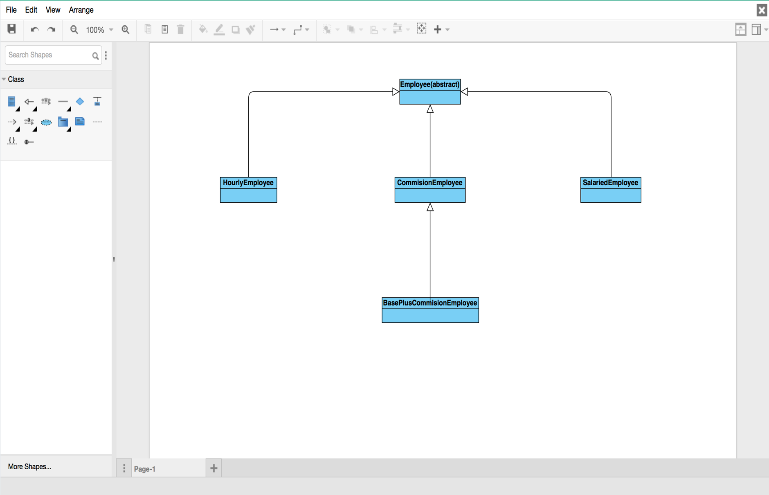

2.) A class diagram and relationship among classes.

